25.9: a) 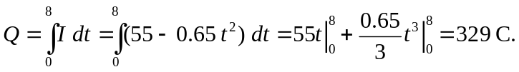
b) The same charge would flow in 10 seconds if there was a constant current of:
